2. Write a pig script to find no of complaints where consumer forum forwarded the complaint same day they received to respective company

//Query

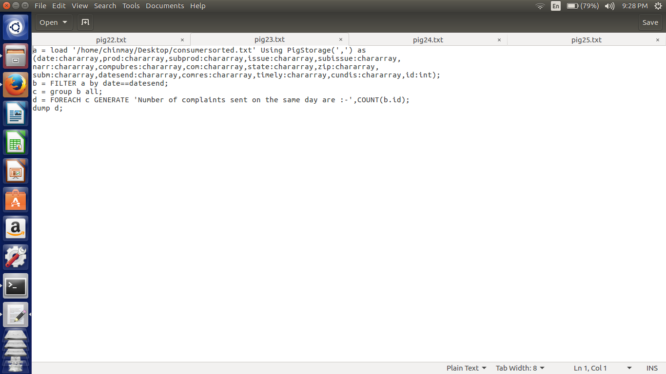

Here in this script first we are loading the file according to respective datatypes. Then we are comparing the date when the complaint was launched and also date when the complaint was forwarded. As both of them are in same format we can directly compare the date.

Again group by all and count the ids to get the number of complaints that got the timely response.

//implementation

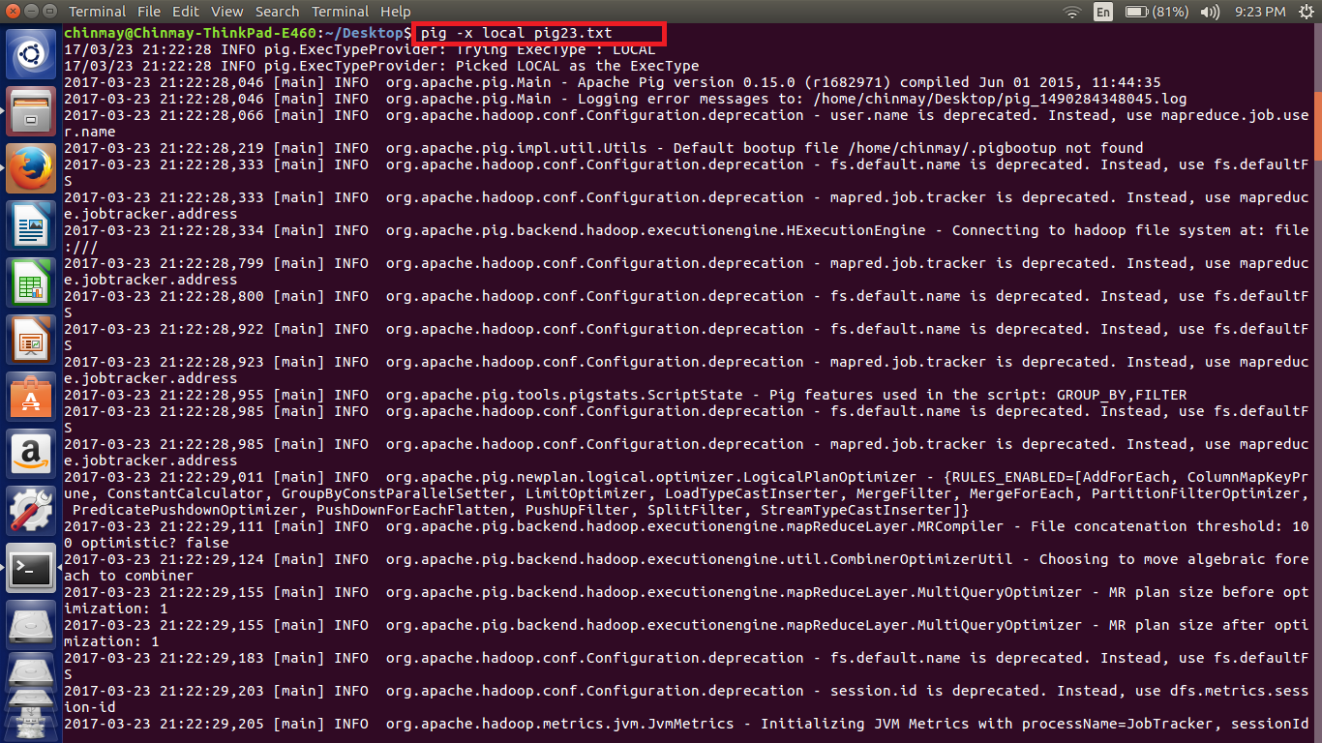

//Output

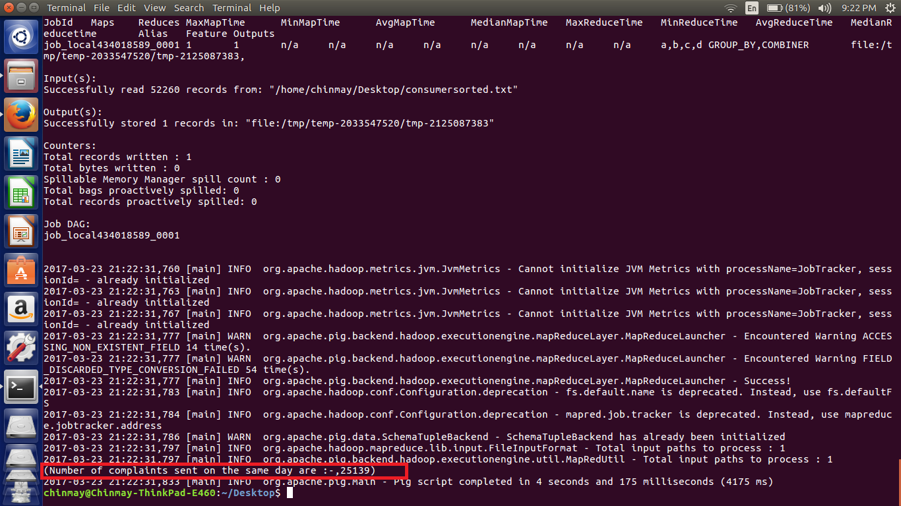

***NOTE - The file used for the implementation is also attached.***